**AMERICAN INTERNATIONAL UNIVERSITY-BANGLADESH**

**Faculty of Science and Technology**



**Course Title: Data Communication[G]**

**Lab Report-5**

**Exp. Title: Study of Digital to Analog Conversion using MATLAB**

***Submitted by:***

|  |  |
| --- | --- |
| **Name** | **ID** |
| Shadril Hassan Shifat | 20-42451-1 |
| Sadia Sultana Ali | 20-42386-1 |
| Abu Shaleh Md. Kaium | 20-42475-1 |
| Md. Ali Ahnaf | 20-42378-1 |

***Submitted to:* Tanjil Amin**

**PerformanceTask:**Assume your ID is **AB-CDEFG-H**, and then convert ‘E’, ‘F’ and ‘G’ to 8 bit ASCII characters and together you have a bit stream of 24 bits. Convert this bit stream to analog signal using the following:

**1.8-ASK, different amplitudes in the modulated signal can be 1:0.5:4.5 for 000 to 111 in that order.**

**MATLAB Code:**

close all;

clc;

clear all;

%ID=AB-CDEFG-H

A=2;

B=0;

C=4;

D=2;

E=4;

F=5;

G=1;

H=1;

% Converting E=4, F=5 and G=1 to 8 bit ASCII characters array

bitStream_1= dec2bin(E,8)-'0';

bitStream_2= dec2bin(F,8)-'0';

bitStream_3= dec2bin(G,8)-'0';

% genarating bit stream array

bitStream= [bitStream_1 bitStream_2 bitStream_3];

% calculating length of bit stream

n=length(bitStream);

ts=2;

%frequency

fd=4.5;

fs=1000;

i=1;

g=0;

while i:3:n

%width of any pulse

t=g*ts:1/fs:(g+1)*ts;

%condition

if bitStream(i)==0 && bitStream(i+1)==0 && bitStream(i+2)==0

ask=1*sin(2*pi*fd*t);

elseif bitStream(i)==0 && bitStream(i+1)==0 && bitStream(i+2)==1

ask=1.5*sin(2*pi*fd*t);

elseif bitStream(i)==0 && bitStream(i+1)==1 && bitStream(i+2)==0

ask=2*sin(2*pi*fd*t);

elseif bitStream(i)==0 && bitStream(i+1)==1 && bitStream(i+2)==1

ask=2.5*sin(2*pi*fd*t);

elseif bitStream(i)==1 && bitStream(i+1)==0 && bitStream(i+2)==0

ask=3*sin(2*pi*fd*t);

elseif bitStream(i)==1 && bitStream(i+1)==0 && bitStream(i+2)==1

ask=3.5*sin(2*pi*fd*t);

elseif bitStream(i)==1 && bitStream(i+1)==1 && bitStream(i+2)==0

ask=4*sin(2*pi*fd*t);

elseif bitStream(i)==1 && bitStream(i+1)==1 && bitStream(i+2)==1

ask=4.5*sin(2*pi*fd*t);

end

%plotting graph

plot(t,ask);

title('8-ASK');

xlabel('time');

ylabel('amplitude')

hold on;

grid on;

i=i+3;

g=g+1;

end;

hold off;

**Output:**

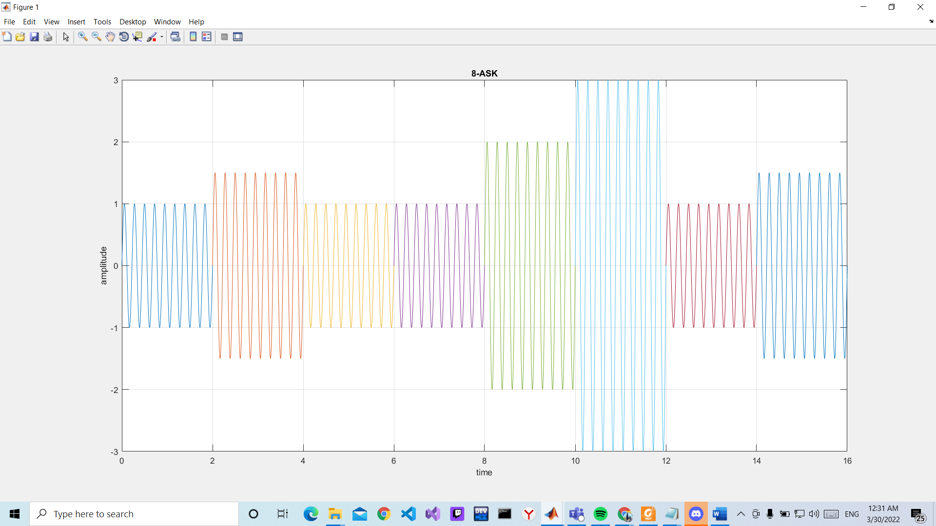

**2.** **8-FSK, different frequencies in the modulated signal can be 1:0.5:4.5 for 000 to 111 in that order.**

**MATLAB Code:**

close all;

clc;

clear all;

%ID=AB-CDEFG-H

A=2;

B=0;

C=4;

D=2;

E=4;

F=5;

G=1;

H=1;

% Converting E=4, F=5 and G=1 to 8 bit ASCII characters array

bitStream_1= dec2bin(E,8)-'0';

bitStream_2= dec2bin(F,8)-'0';

bitStream_3= dec2bin(G,8)-'0';

% genarating bit stream array

bitStream= [bitStream_1 bitStream_2 bitStream_3];

% calculating length of bit stream

n=length(bitStream);

ts=2;

%frequency

fd=4.5;

fs=1000;

i=1;

g=0;

while i:3:n

%width of any pulse

t=g*ts:1/fs:(g+1)*ts;

%condition

if bitStream(i)==0 && bitStream(i+1)==0 && bitStream(i+2)==0

fsk=4.5*sin(2*pi*t);

elseif bitStream(i)==0 && bitStream(i+1)==0 && bitStream(i+2)==1

fsk=4.5*sin(2*pi*1.5*t);

elseif bitStream(i)==0 && bitStream(i+1)==1 && bitStream(i+2)==0

fsk=4.5*sin(2*pi*2*t);

elseif bitStream(i)==0 && bitStream(i+1)==1 && bitStream(i+2)==1

fsk=4.5*sin(2*pi*2.5*t);

elseif bitStream(i)==1 && bitStream(i+1)==0 && bitStream(i+2)==0

fsk=4.5*sin(2*pi*3*t);

elseif bitStream(i)==1 && bitStream(i+1)==0 && bitStream(i+2)==1

fsk=4.5*sin(2*pi*3.5*t);

elseif bitStream(i)==1 && bitStream(i+1)==1 && bitStream(i+2)==0

fsk=4.5*sin(2*pi*4*t);

elseif bitStream(i)==1 && bitStream(i+1)==1 && bitStream(i+2)==1

fsk=4.5*sin(2*pi*4.5*t);

end

%plotting graph

plot(t,fsk);

hold on;

grid on;

title('8-FSK');

xlabel('time');

ylabel('amplitude')

i=i+3;

g=g+1;

end;

hold off;

**Output:**

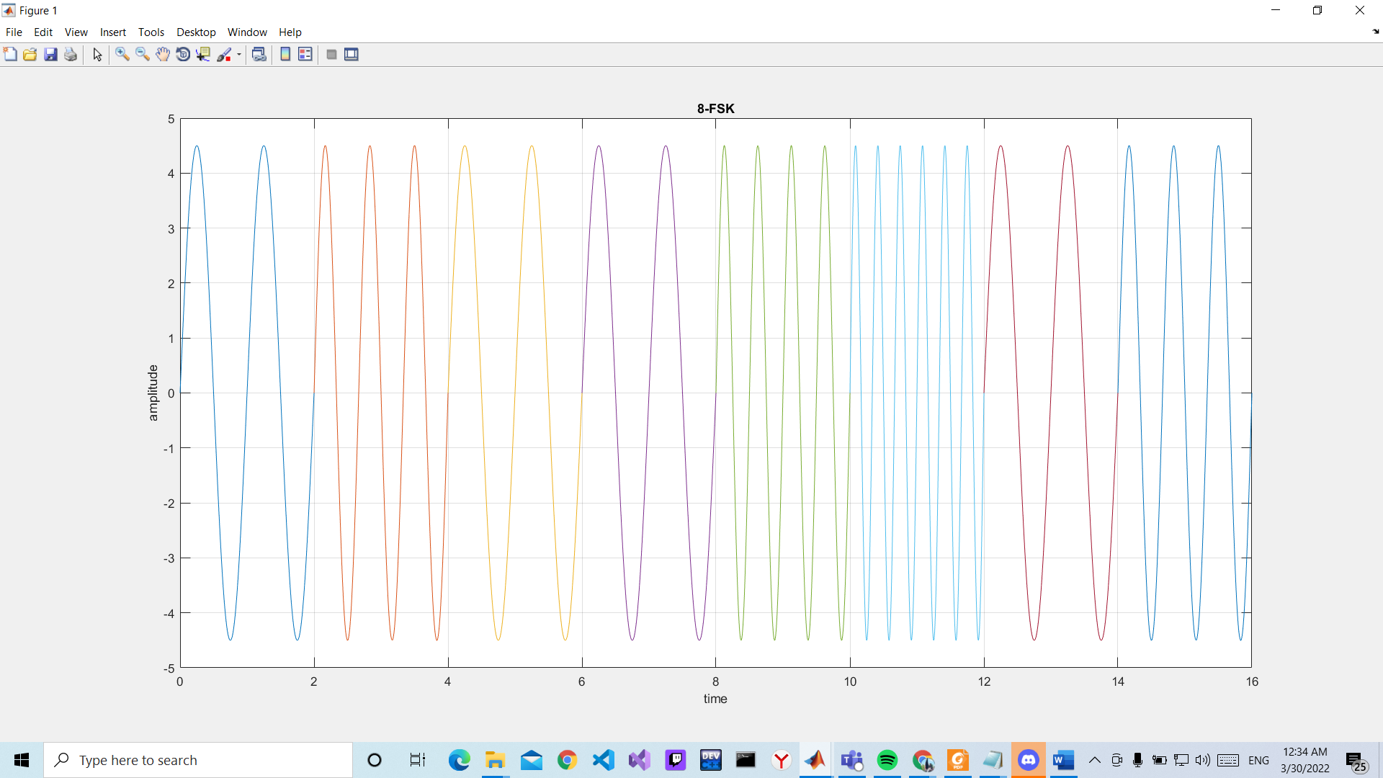

**3. 8-PSK, different phases in the modulated signal can be 0◦:45◦:315◦ for 000 to 111 in that order.**

**MATLAB Code:**

close all;

clc;

clear all;

%ID=AB-CDEFG-H

A=2;

B=0;

C=4;

D=2;

E=4;

F=5;

G=1;

H=1;

% Converting E=4, F=5 and G=1 to 8 bit ASCII characters array

bitStream_1= dec2bin(E,8)-'0';

bitStream_2= dec2bin(F,8)-'0';

bitStream_3= dec2bin(G,8)-'0';

% genarating bit stream array

bitStream= [bitStream_1 bitStream_2 bitStream_3];

% calculating length of bit stream

n=length(bitStream);

ts=2;

%frequency

fd=4.5;

fs=1000;

i=1;

g=0;

while i:3:n

%width of any pulse

t=g*ts:1/fs:(g+1)*ts;

%condition

if bitStream(i)==0 && bitStream(i+1)==0 && bitStream(i+2)==0

psk=4.5*sin(2*pi*fd*t);

elseif bitStream(i)==0 && bitStream(i+1)==0 && bitStream(i+2)==1

psk=4.5*sin(2*pi*fd*t+pi/4);

elseif bitStream(i)==0 && bitStream(i+1)==1 && bitStream(i+2)==0

psk=4.5*sin(2*pi*fd*t+pi/2);

elseif bitStream(i)==0 && bitStream(i+1)==1 && bitStream(i+2)==1

psk=4.5*sin(2*pi*fd*t+(3*pi)/4);

elseif bitStream(i)==1 && bitStream(i+1)==0 && bitStream(i+2)==0

psk=4.5*sin(2*pi*fd*t+pi);

elseif bitStream(i)==1 && bitStream(i+1)==0 && bitStream(i+2)==1

psk=4.5*sin(2*pi*fd*t+pi+pi/4);

elseif bitStream(i)==1 && bitStream(i+1)==1 && bitStream(i+2)==0

psk=4.5*sin(2*pi*fd*t+pi+pi/2);

elseif bitStream(i)==1 && bitStream(i+1)==1 && bitStream(i+2)==1

psk=4.5*sin(2*pi*fd*t+pi+(3*pi)/4);

end

%plotting graph

plot(t,psk);

title('8-PSK');

xlabel('time');

ylabel('amplitude')

hold on;

grid on;

i=i+3;

g=g+1;

end;

hold off;

**Output:**

